PROJECT OBJECTIVES

|  |  |
| --- | --- |
| Date | 19 September 2022 |
| Team ID | PNT2022TMID31916 |
| Project Name | Visualizing and Predicting Heart Diseases with an Interactive Dash Board. |
| Maximum Marks | 4 Marks |

# Problem Statement:

The leading cause of death in the developed world is heart disease. Therefore, there needs to be work done to help prevent the risks of having a heart attack or stroke.

# Technical Architecture:

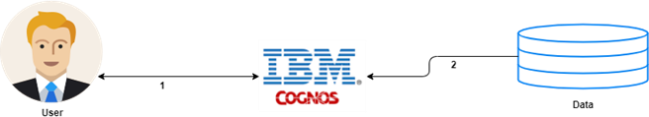

**Project Objectives:**

By the end of this Project, one will:

* Know fundamental concepts and can work on IBM Cognos Analytics
* Gain a broad understanding of plotting different visualizations to provide a suitable solution.
* Able to create meaningful Visualizations and Dashboard(s).